**Tutoring Coordinator Module WireFrames:**

1. **Login Page**

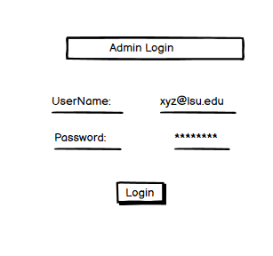

1. **Home Page**

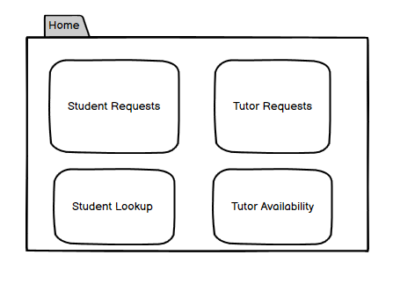

1. **Student Requests  
   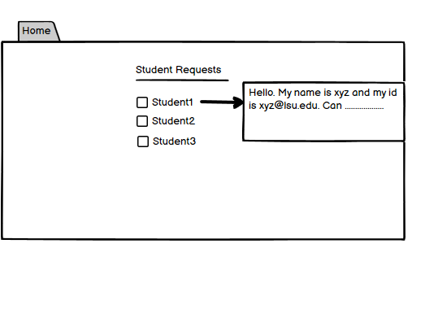**
2. **Tutor Requests  
   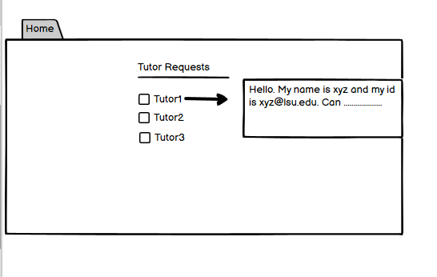**
3. **Student Lookup  
   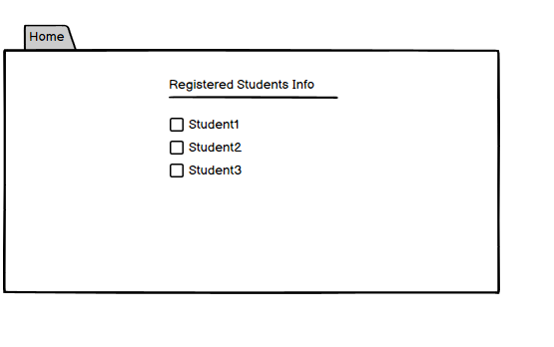**
4. **Professor Info**

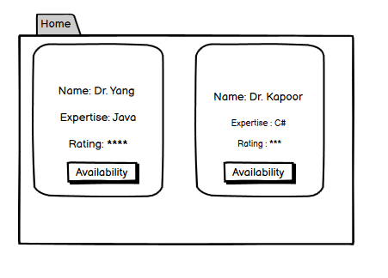

1. **Check Availability**

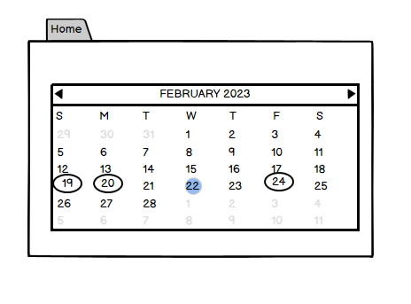

1. **Modify Time Slot**

